Student Projects

Sr.  No. | Team/Project Description | Project status at beginning of the Year | Interventions Made | Current Status
1 | IoT based Smart Street Lighting System, Light automatically adjusts its intensity as per background for energy savings. | NIL, New Project | The protype has been demonstrated as live deployment in the identified location at IIIT-A. The scaling is not possible till the project is properly fabrication, which is being worked over. | Prototype is ready. The team is struggle with the miniaturization and fabrication.
2 | A Portable Corona-Discharge System with Custom Made Electrodes for PDMS Hydrophilic treatment and Bonding for Microfluidic Chip Fabrication and Cost Effective Micro Impedance Pump For Potential Application in the Micro-fluidics & Bio-Medical Domain, A device with medical applications | NIL, New Project | The prototype has been developed and demonstrated at sister labs. The product has been customized and made compact to suit the user requirements. | The proof of concept is done. Commercialization options are being sought.
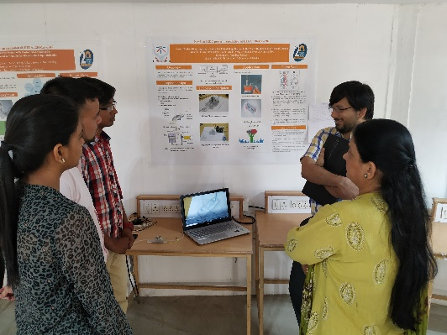
3 | Desi Drone for Healthcare Sector in India – “Chikitsa PS-1925”, A drone that delivers medical samples for efficient delivery | NIL, New Project | The drone design is done. The user application is being developed. | The project is in the development stage.
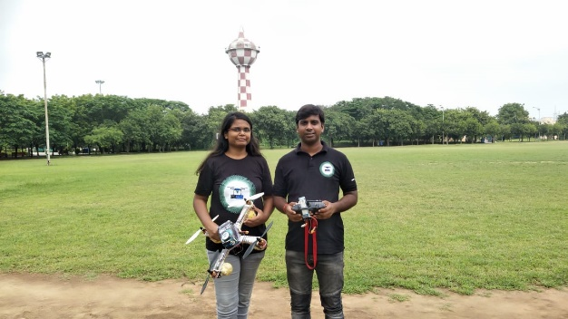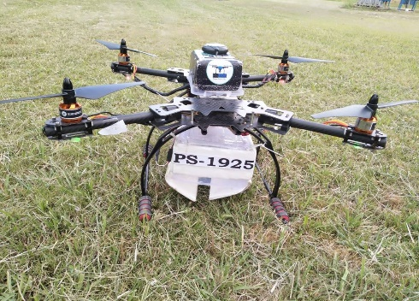
4 | Advanced Bio-3Dprinters and Multi domain 3D Printing Services | NIL, New Project | 3D printers were made and various structures related to the medical domain are printed to check its efficiency of printing and found to be up to the mark. | Website is being made so as to provide the platform of service being served to the  needy. We have found our customers ready to take our service.
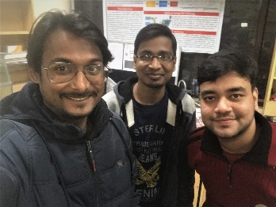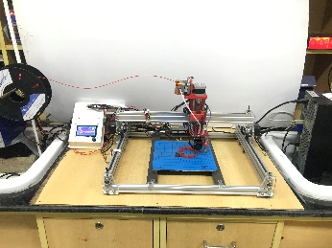
5 | Women Safety Ring, Ring can be triggered in case of emergencies | NIL, New Project | 1)Cloud server(Firebase) established between pi and Android Application  2)Android Application completed  3)Audio and Video recodings are uploaded successfully via cloud database. | In prototype stage.  In contact with DLab and THub to convert the prototype into product.
6 | OGO – The place for bikes and e-bikes, Engineering an e-bike and giving rental services at tourist places | NIL, New Project | E-bicycle, have designed and developed the prototype for an electric bicycle. Successfully converted a regular bicycle to electric bike with pedal assist and results tested with multiple user surveys. | Ready with the prototype and recently raise 3 orders from the customers. Have a plan to provide 10 E-bicycle for the IIIT-A campus and ready for commercialization.
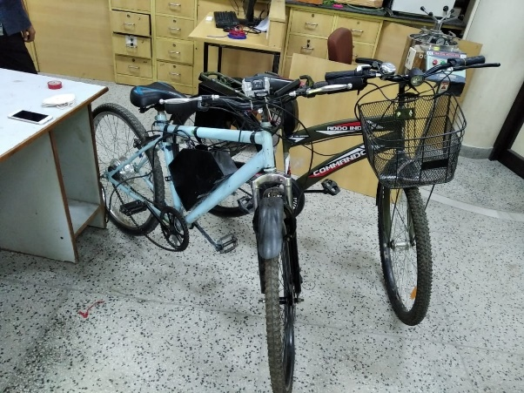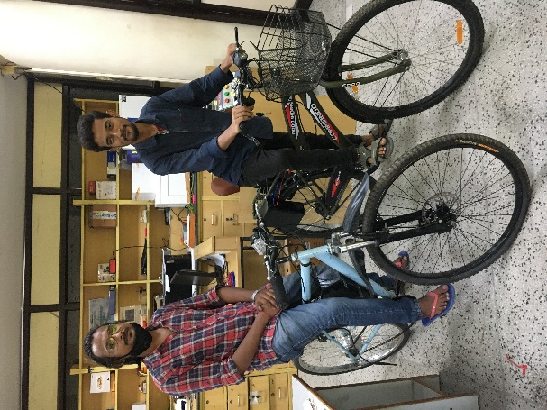
7 | An Alexa controlled smart surveillance robot, Service robot that is affordable for homes | NIL, New Project | Reached to a state where our robot is able to generate a map and estimate the semantics involved in the environment. It can be used by virtual agent for further HRI task. | Project is in the development stage
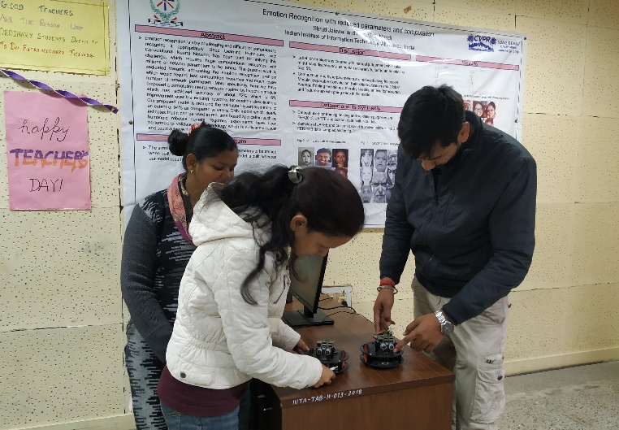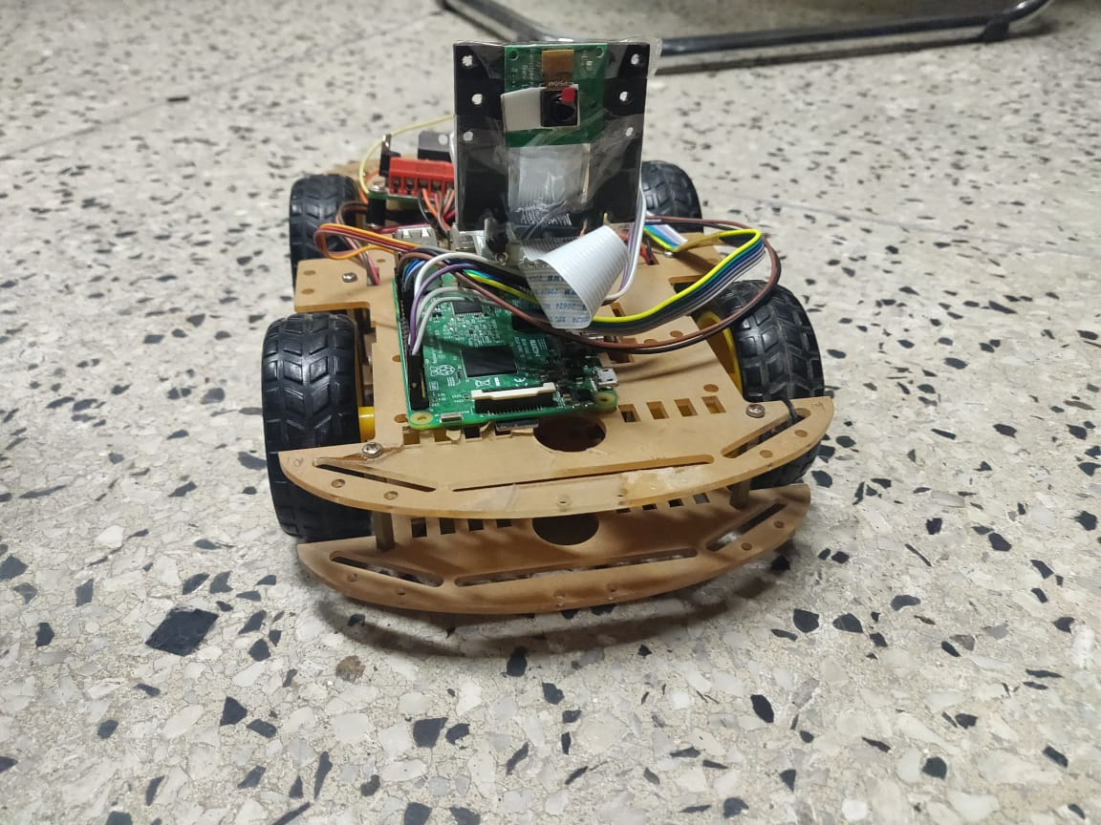
8 | Safest Route, Get the safest route to commute within cities based on mined historic police records. | NIL, New Project | Prototype is developed and demonstrated. The product requires a reasonable amount of data which is not currently available. | The project is being re-thought in the lines of data requirements.
9 | SCAB (Sharing-Cab), Share a cab with your friends only to commute between common places in a city. | NIL, New Project | i) The mobile app is rebuilt on Flutter and was going to be launched after the Holi holidays but it has to be postponed due to the pandemic and we will launch it whenever the college reopens.  ii) The marketing strategy for promotion has been planned and is being worked on. Also, a google play account has been procured | To be launched soon after institute reopens
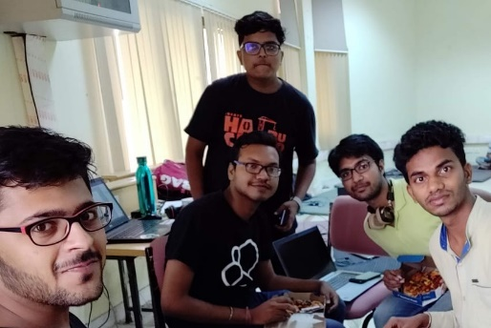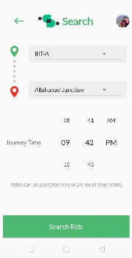
10 | Advanced Energy efficient Home Automation, Smart home that saves energy | NIL, New Project | A proof of concept for various use cases has already been demonstrated in multiple venues. The team is currently struggle on miniaturization and fabrication. As per suggestions, the team also wishes to try a more competitive related idea. | Prototype is ready, needs to be improved to make a product.
11 | AmuseBag, Personalized gifting which is actually of high value for the recipient | NIL, New Project | The website is ready(amusebag.com) we have shifted our focus on 7-12yrs kids market, and researched and bought products for it. | To go to retailers for the collaborations
